

**Automated Attendance Tracking System – High Level Use Case Document**

**Kyare Joaquino**

**Jemar Carlos**

**Edward Jedah Arabia**

**BACHELOR OF SCIENCE IN INFORMATION TECHNOLOGY**

**MAY 2025**

**Overview**

This document describes the key interactions between various users and the system within an educational management platform. The primary user roles Administrators, Instructors, and Students each have distinct responsibilities and functions.

**HIGH LEVEL USE CASE DIAGRAM**

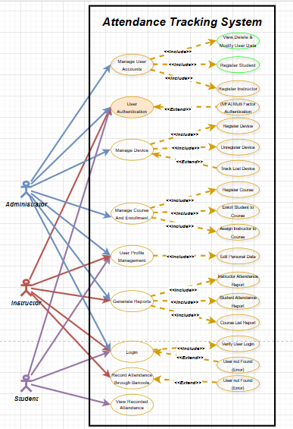

**ACTOR AND THEIR RESPONSIBILITIES:**

* Admin: Oversees system-wide operations including user account control, device oversight, course setup, and report generation.
* Instructor: Handles course management, report access, and student attendance evaluation.
* Student: Can view attendance records and manage registration and profile settings.

**User Account Management:**

**Actor**: Administrator

Description: Administrators are responsible for creating, modifying, enabling, disabling, deleting, and viewing instructor and student accounts.

**Extensions**:

* Register Instructor: Add a new instructor profile.
* Register Student: Create a new student account.
* Delete/View User Data: Manage existing user information and access profiles.

**User Authentication:**

**Actor**: All users (Administrator, Instructor, Student)

**Description**: Authentication is required for users to access system functionalities.

**Extensions**:

* Multi-Factor Authentication (MFA): Enhances login security with an additional verification step.

**Device Management:**

**Actor**: Administrator

Description: Enables the admin to register, deregister, and locate lost user-linked devices.

**Extensions**:

* Register Device: Add a new device to the system.
* Unregister Device: Remove a device from the system.
* Track Lost Device: Locate devices flagged as lost for security purposes.

**Course and Enrollment Management:**

**Actor**: Administrator

**Description**: Admins are responsible for creating courses, assigning instructors, and enrolling students.

**Extensions**:

* Register Course: Initiate new course offerings.
* Assign Instructor to Course: Allocate instructors to specific courses.
* Enroll Student in Course: Add students to designated courses.

**User Profile Management:**

**Actor**: All users (Administrator, Instructor, Student)

**Description**: Users can view and update their own personal and account information.

**Report Generation:**

**Actor**: All users (Administrator, Instructor, Student)

**Description**: Generate reports relating to users, courses, and system activities.

**Extensions**:

* Instructor List Report: Display all registered instructors.
* Student List Report: View all student users.
* Course List Report: Access a directory of current course offerings.

**Login**

**Actor**: All users

**Description**: Users sign into the platform using their credentials.

**Extensions**:

* Verify Login: Validate login details for access.
* Error Message: Notify users of unsuccessful login attempts.

**Attendance Recording via Barcode**

**Actor**: Instructor or designated personnel

**Description**: Attendance is marked by scanning a student’s barcode ID.

**Extensions**:

* Mark Student Dropped: Identify students who have withdrawn from the course during attendance tracking.

**View Attendance Records:**

**Actor**: Student

**Description**: Students can access a record of their attendance history for each course.  
  
  
**Summary**:

This comprehensive use case overview illustrates the central interactions between user roles and system functionalities within the educational management platform. It captures essential processes such as user and course management, device oversight, attendance tracking, authentication, and report generation. Each user type Administrator, Instructor, and Student is equipped with tailored permissions aligned to their roles, ensuring efficient and secure system use.

Furthermore, the platform's modular architecture allows for seamless feature expansion and future integrations with other academic systems. Its scalable design positions it as both a robust solution for current institutional requirements and a forward-compatible foundation capable of adapting to emerging educational and technological needs.

Thank You.